1. **What does a set operator do?**

The set operator combines the rows from two queries

1. **What are the general requirements of a set operator**

The two input queries must produce results with the same number of columns, and corresponding columns must have compatible data types. The subquery cannot have an order by clause. The names of the new columns are determined by the first query

1. **What is a Venn Diagram? This is not in the book.**

A Venn diagram represents mathematical or logical sets pictorially as circles, visualizing all possible logical relations between different sets.

1. **Draw a Venn Diagram of the UNION operator. What does it do?**

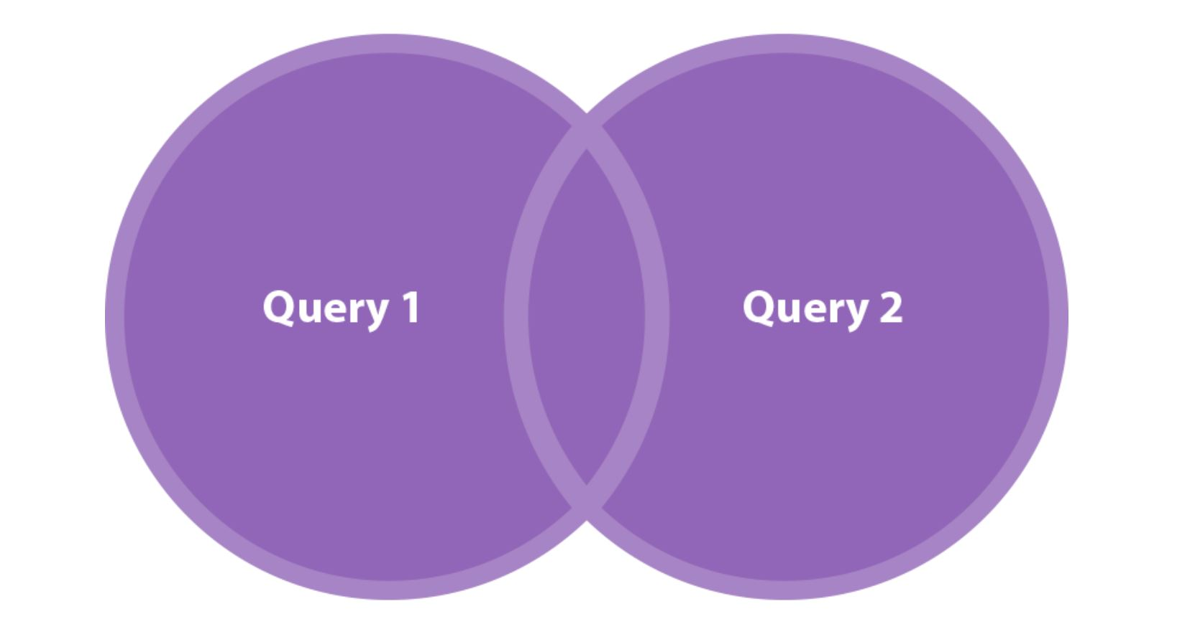

The UNION operator unifies all the results of two queries, leaving out repeating rows.

1. **Draw a Venn Diagram of the UNION ALL operator. What does it do?**

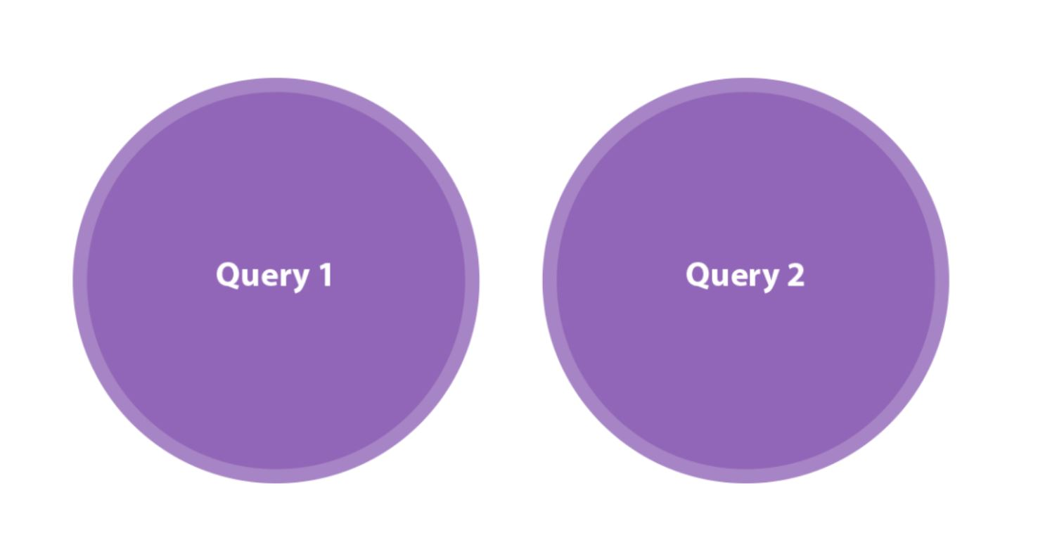

The UNION ALL operator unifies the two input query results without attempting to remove duplicates from the result and returns all rows of both tables.

1. **Draw a Venn Diagram of the INTERSECT operator. What does it do?**

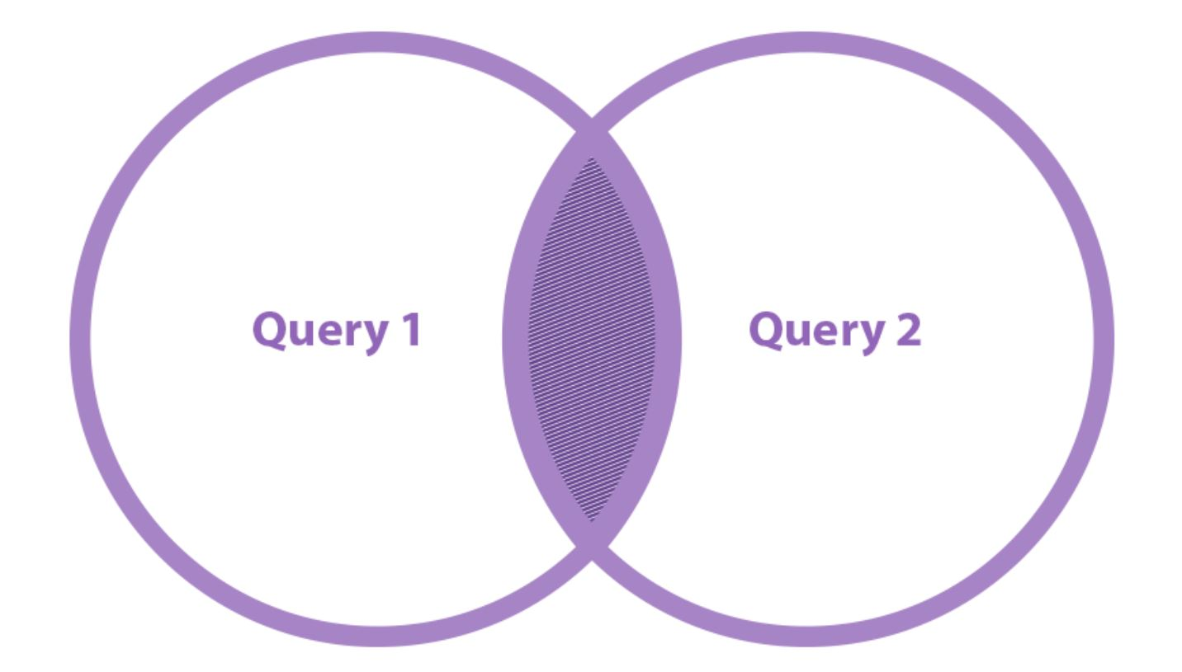

INTERSECT shows which items are shared between the two queries, and returns only distinct rows that appear in both input query results.

1. **If SQL Server supported the INTERSECT ALL operator, what would it do?**

INTERSECT ALL would show which items are shared between the two queries, but duplicate intersections would not be removed.

1. **Draw a Venn Diagram of the EXCEPT operator. What does it do?**

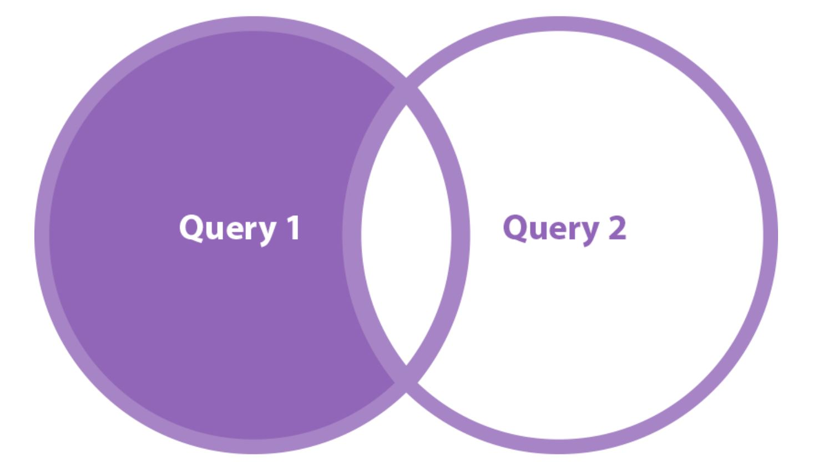

The EXCEPT operator implements set differences. It operates on the results of two input queries and returns rows that appear in the first input but not the second.

1. **If SQL Server supported the EXCEPT ALL operator, what would it do?**

The EXCEPT ALL operator would be similar to the EXCEPT operator, but it would also take into account the number of occurrences of each row.

1. **What is the precedence of the set operators?**

The INTERSECT operator precedes UNION and EXCEPT; UNION and EXCEPT are evaluated in order of appearance.